***Charting the course of innovation:***

***a startup analysis***

**INTRODUCTION:**

**OVERVIEW:**

Starting a new company can be an exciting and rewarding experience, but it also requires careful planning and analysis to ensure that the business is viable and successful. There are several key areas that you should focus on when conducting a startup company analysis. Conducting a thorough analysis of these areas can help you identify potential challenges and opportunities, and develop strategies to address them. It is also important to regularly review and update your analysis as the business progresses, in order to adapt to changing market conditions.

**PURPOSE:**

The purpose of a startup is multi-faceted, depending on the individual or team behind the venture. Generally, though, the purpose of a startup is to create something new and innovative. A startup is often the first step in launching a business venture, and is the beginning of an entrepreneurial journey.

Startups are created to fill a void in the marketplace, or to take advantage of a new trend or opportunity. They are often driven by ambitious individuals with a desire to make money or have an impact on the world by developing a product or service that is unique. Startups often start small and grow as they attract funding or customers.

Startups can be used to test out ideas, explore new technologies, and develop products and services that can eventually turn into successful businesses. Startups often rely on venture capital funding to get off the ground and are typically run by entrepreneurs who are passionate about their ideas.

In addition to creating something new, startups are also about problem-solving. They look for innovative ways to solve existing problems or create solutions to challenges that people face in their daily lives. Startups can also be used to create new markets and disrupt existing ones by offering something that was previously unavailable or too costly for most people.

Startups aren't limited to technology-related businesses either; they can be found in almost any industry. From fashion startups to food startups, there is an endless array of potential business ventures that can be launched under the umbrella of a startup.

Regardless of what industry they are in, startups are all about taking risks and pushing boundaries in order to create something innovative and valuable. They are often backed by investors who provide funding in exchange for a stake in the company, which gives them the opportunity to reap the rewards of success if things go well.

Ultimately, the purpose of a startup is to fulfil an ambition or goals bring an idea to life and turn it into something tangible and meaningful. Whether it's making money, having an impact on society, or simply following one’s passion, startups provide individuals with the opportunity to pursue their dreams and create something extraordinary.

**PROBLEM DEFINITION & DESIGN THINKING:**

**EMPATHY MAP:**

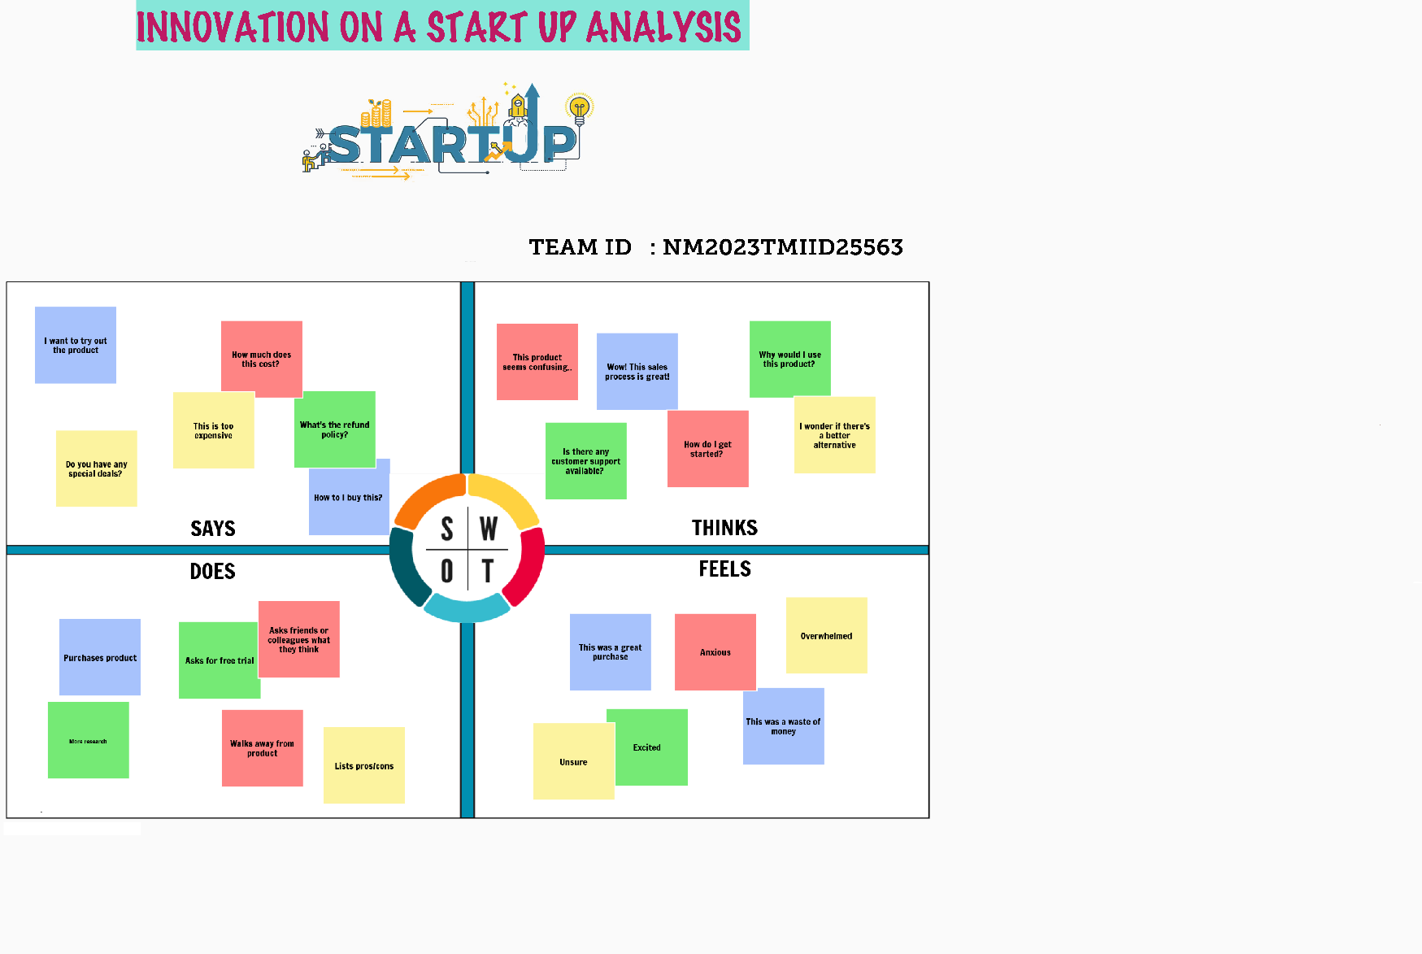

**IDEATION & BRAINSTORMING MAP:**

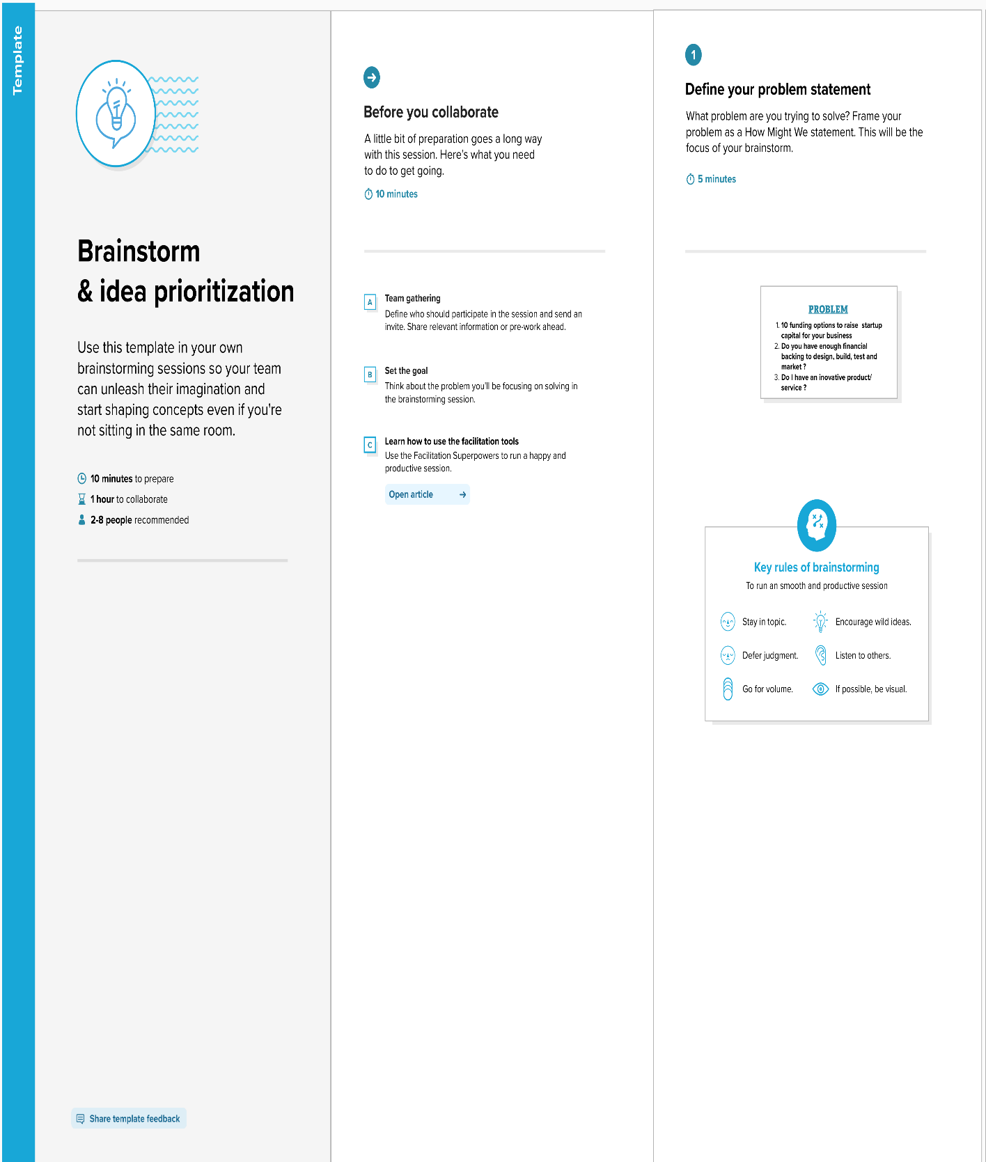

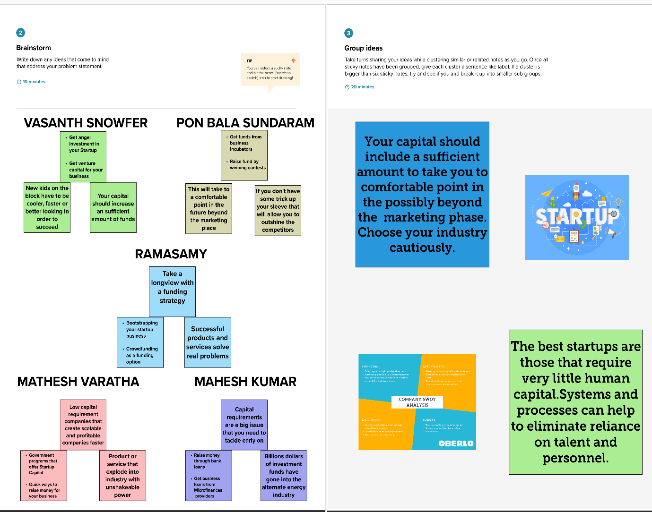

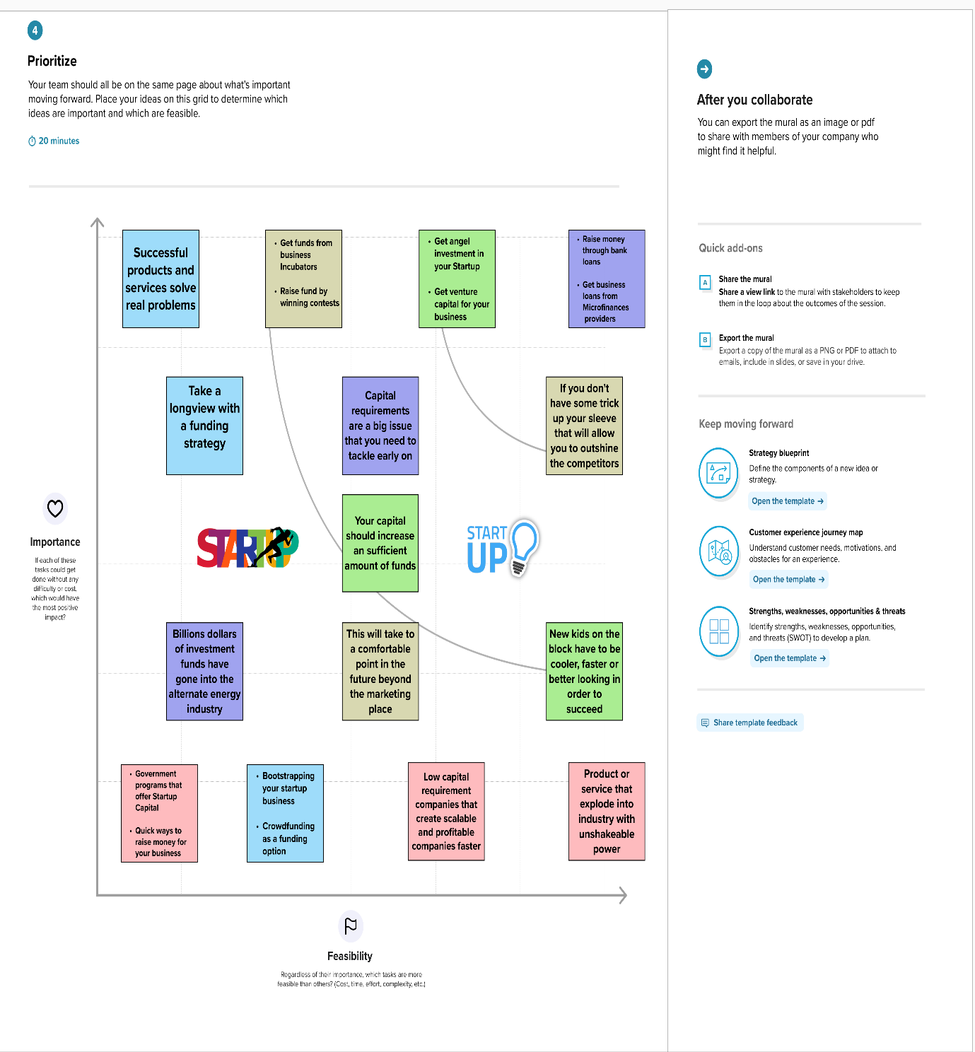

**RESULT:**

**NUMBER OF STARTUPS BY YEAR:**

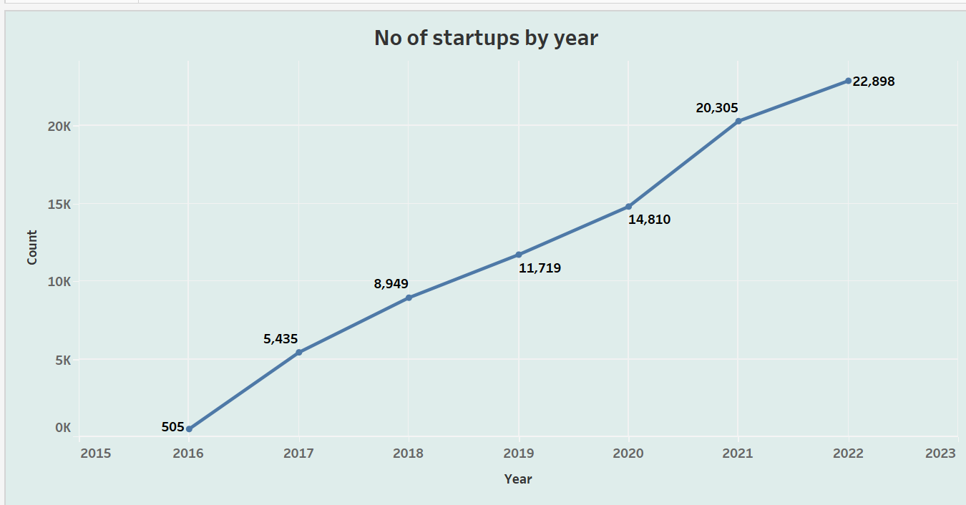

**NUMBER OF STARTUPS INDUSTRY WISE:**

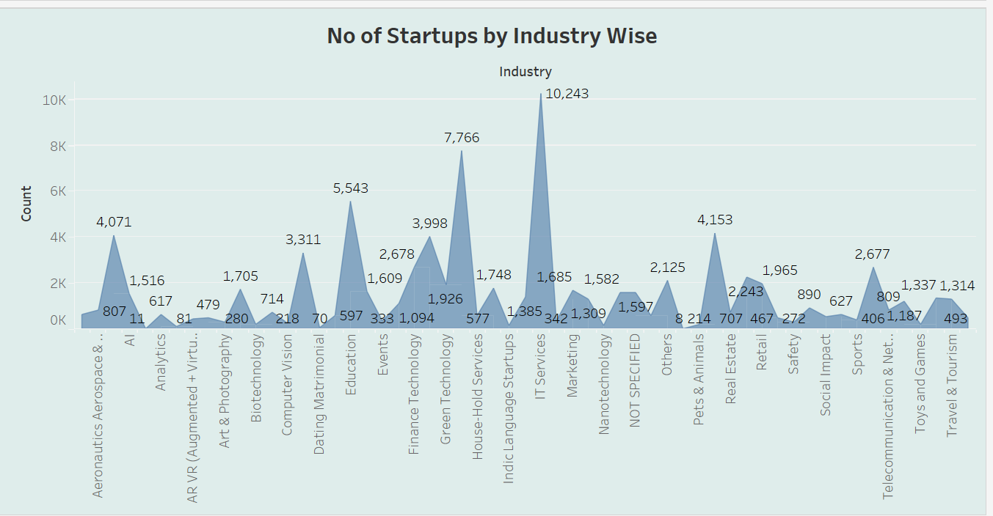

**NUMBER OF STARTUPS BY STATE:**

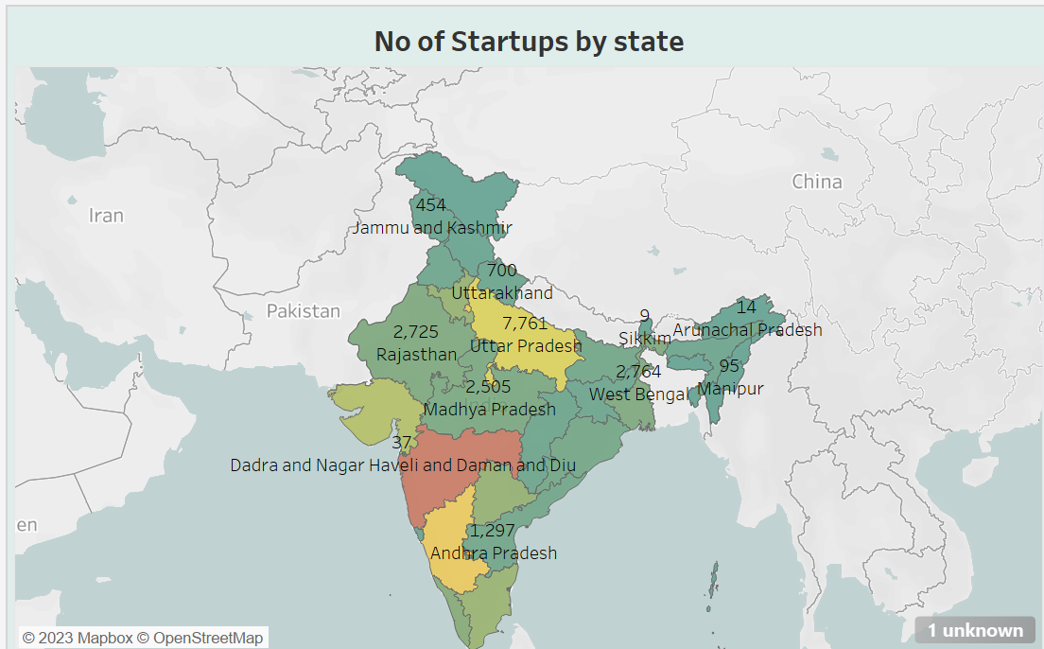

**TOP 10 INDUSTRIES BY NO. OF STARTUPS:**

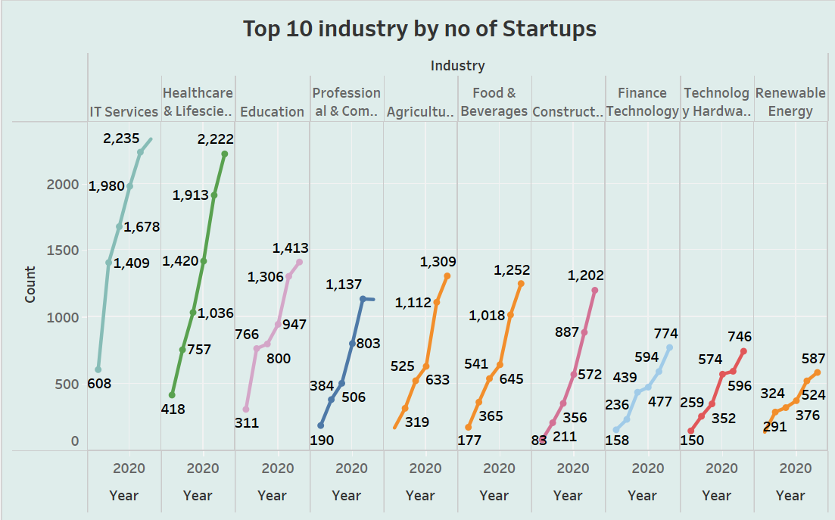

**NUMBER OF STARTUPS BY YEAR AND APPPLYING FILLERS OF INDUSTRY AND STATE:**

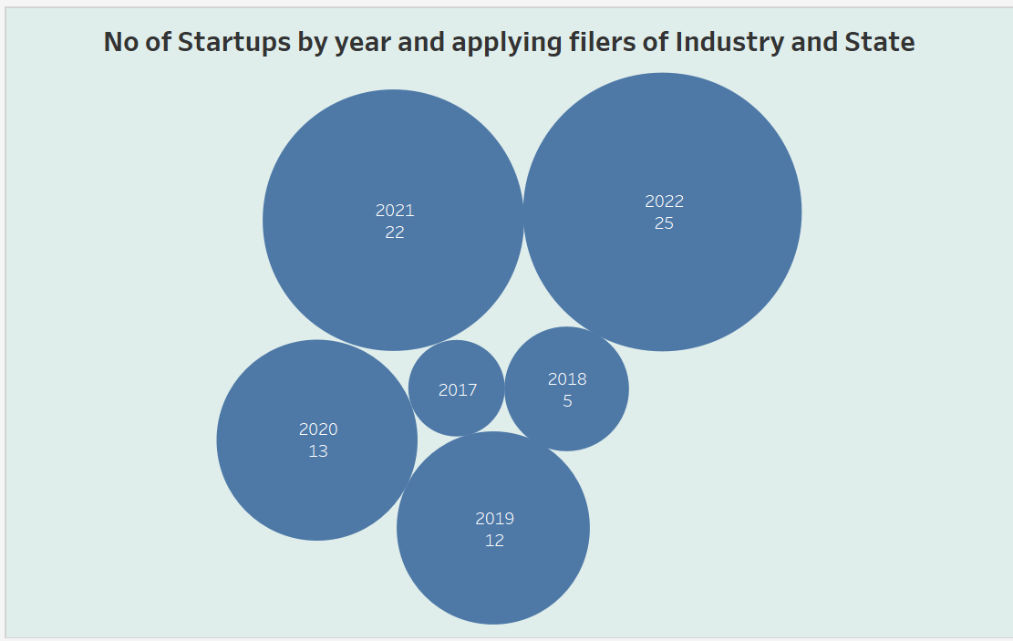

**INDUSTRY: TOP 10 INDUSTRIES AND TOP 10 STATES BY EACH:**

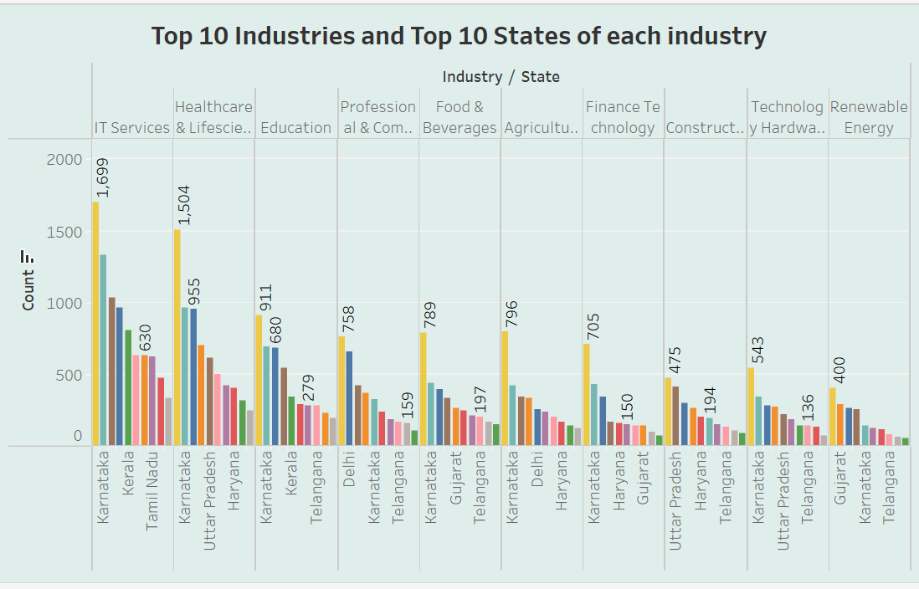

**TOP 10 STATES BY NO. OF. STARTUPS:**

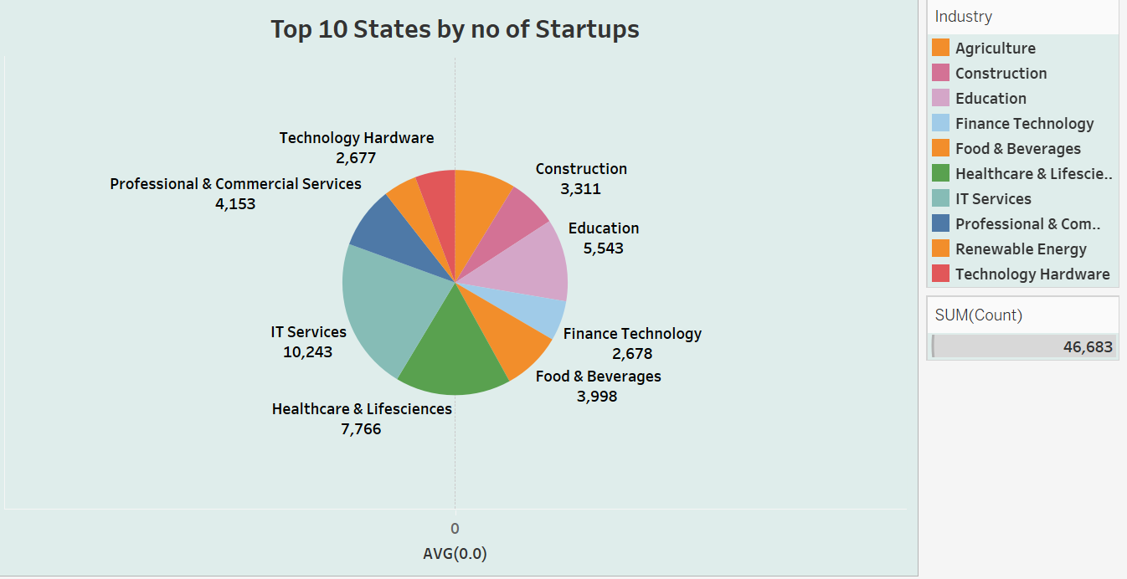

**ADVANTAGES OF STARTUP:**

**1.Understanding the market**

**2. Getting to know your business well**

**3. Clarifying the weaknesses of your competitors**

**4. Weighting your competitor`s strength**

**5.**[**Market potential forecasting**](https://smallbusiness.chron.com/methods-market-forecasting-62491.html)

**6. Reveling your vulnerable spots**

**7. Knowing what makes your customers being interested in a specific product or service and what encourages them to buy it**

**8. Expecting disagreements and objection**

**9. Learning from the mistakes of others**

**10. Advancing your closing techniques**

**11. Getting an awareness of competitor pricing**

**12. Minimizing risks of making mistake during**

**defining the best ways to designing your product**

**13. Being on a lookout for good ideas**

**14. Understanding economic climate tracking**

**15. Choosing the best market entry strategy.**

**DISADVANTAGES OF STARTUP ANALYSIS:**

1. Uncertain job security
2. A heavy workload
3. Long hours
4. Less pay
5. Lack of structure
6. Constant change
7. Limited resource
8. Too much freedom.

**APPLICATIONS:**

**➤ The term startup refers to a company in the first stages of operations.**

**➤ Startups are founded by one or more entrepreneurs who want to develop a product or service for which they believe there is demand**

**➤ A startup analysis is essential to the success of any startup business.**

**➤ It allows entrepreneurs to identify the key areas that need improvement and make necessary changes early on.**

**➤ Doing a startup analysis also allows startups to track their progress and ensure that they are on track to achieve their goals**.

**CONCLUSION**:

**★ NUMBER OF STARTUPS BY YEAR:**

**★ NUMBER OF STARTUPS INDUSTRY WISE:**

**★ NUMBER OF STARTUPS BY STATE:**

**★ TOP 10 INDUSTRIES BY NO. OF STARTUPS:**

**★ NUMBER OF STARTUPS BY YEAR AND APPPLYING FILLERS OF INDUSTRY AND STATE:**

**★ INDUSTRY: TOP 10 INDUSTRIES AND TOP 10 STATES BY EACH**

**★ TOP 10 STATES BY NO. OF. STARTUPS:**

**FUTURE SCOPE:**

**Banking**

**To improve customer service and performance, banking sector companies rely on predictive analytics. As banking and financial institutions embark upon new technologies such as blockchain and data analytics, the future Scope of Data Analytics in India, especially banks is quite promising.**

**Manufacturing**

**Data analytics provides the information needed by production plant managers to keep customers satisfied when the market needs to alter.**

**Retail**

**To help retail staff better understand what drives customers to buy and which incentives are most likely to provide the desired results, enormous amounts of data can be used to create predictions.**

**Health Car**

**Analytics can assist doctors in establishing an accurate diagnosis or determining the likely results of treatments for people suffering from specific ailments. The Healthcare industry is probably one of the most promising ones when it comes to the future Scope of Data Analytics in India.**

**Information and Communications Technology**

**The most advanced cyber defence systems rely heavily on data science. Information technology benefits from the expertise of data scientists. Moreover, they are working together with cyber security experts to combat the challenges faced by the sector.**

**What are the job opportunities after B.tech in Data Analytics in India?**

**Engineers that specialise in data analysis will be needed for the following positions in the future:**

**Data Protection**

**Information security will benefit greatly from the developments in the field of data analytics Data engineers will find numerous opportunities in the domains of differential privacy, cybersecurity, virtual watermarking, and malware detetction.**

**Internet of Things (IoT)**

**We should expect the Internet of Things (IoT) to continue to grow at an exponential rate. IoT-generated structured and unstructured data will require more sophisticated analytics tools and techniques.**

**Growth of Cognitive Analytics**

**We could see a significant rise in cognitive analysis in the next several days. The future of information analytics is bolstered by the fact that companies will be more vocal about their needs and utilise data to the fullest extent possible to secure financial gain**

**Boost in demand for Data Scientists**

**The demand for Data Scientists is on the rise, emphasising individuals who can combine quantitative analysis skills with the ability to convey their findings in compelling and visually appealing ways.**

**Data Accuracy**

**Data Accuracy would become a significant concern for businesses as they embark upon datasets to forecasts business trends.**

**By 2024, data is expected to have multiplied by 50. To avoid becoming obsolete, companies must keep up with the demands of large volumes of data. Businesses that want to adapt their business models and stay one step ahead of the competition rely on experts with superior analytical skills.**

**Dashboard of Startup Analysis is mentioned in below link**

<https://public.tableau.com/views/Dashboard1_16817138361690/Dashboard1?:language=en-US&:display_count=n&:origin=viz_share_link>

**Story of Startup Analysis is mentioned in below link**

<https://public.tableau.com/views/Story1_16817139327840/Story1?:language=en-US&:display_count=n&:origin=viz_share_link>

APPENDIX:

**SOURCE CODE:**

**THIS LINK BELOW SHOWS THE PROJECT**

**file:///C:/Users/mahar/Downloads/Arsha/Arsha/index.html**